

Product Dissection for Linkedin

**Company Overview:**

Linkedin Corporation is a global social networking website designed for professionals and corporations. Founded in 2002 and acquired by Microsoft in 2016, it acts as a platform for individuals to create professional profiles, network with colleagues, and look for work. Companies can create a presence on the platform to market their services and employment openings. Users interact with Linkedin via a variety of features such as content sharing, messaging, and professional groups. It also provides a large collection of courses through Linkedin Learning, which aids in professional development. The platform's major purpose is to enable networking, career development, and knowledge exchange, making it a must-have tool for job seekers, recruiters, and professionals across industries.

**Product Dissection and Real World problems solved by Linkedin:**

Upon dissecting the product, several key features are revealed. Users construct personalised profiles that serve as digital resumes, highlighting their employment experience, abilities, endorsements, and educational background. These profiles form the basis for networking and professional development. LinkedIn allows users to connect with other professionals, resulting in a large network of contacts.

Linkedin handles a number of real-world issues and has evolved into a vital professional tool. First and foremost, it makes the job search process more efficient.

Job seekers can readily identify jobs that match their credentials and interests, while businesses can tap into a large talent pool. Linkedin simplifies the recruitment process by providing a platform for brand promotion and talent acquisition. It also promotes networking by linking professionals from various industries and geographical regions, making it an effective approach to broaden one's professional network and pursue employment prospects. It also provides significant insights into salary trends, which help professionals negotiate fair compensation.

Linkedin Learning addresses the demand for continual skill development by providing a wide range of courses on numerous topics, helping users to remain relevant in an ever-changing employment market. LinkedIn addresses real-world issues in the areas of employment, professional networking, and career advancement.

**Case Study: Real-World Problems and Linkedin’s Innovative Solutions**

Linkedin Learning meets the demand for ongoing skill development by offering a diverse choice of courses on a variety of topics, allowing users to stay relevant in an ever-changing job market. Linkedin addresses real-world concerns related to employment, professional networking, and career growth.

**Problem 1: Networking and Professional Connections**

**Real-World Challenge:** Professionals frequently struggle to broaden their network, make significant connections, and seize chances beyond their narrow circles.

**LinkedIn's Solution:** LinkedIn has transformed networking. Users can connect with professionals from all around the world, join industry-specific groups, and interact with the material. This vast network enables introductions, career growth, and collaboration.

**Problem 2: Job Search and Recruitment**

**Real-World Challenge:** Both job searchers and companies struggle to find relevant openings and identify qualified candidates.

**LinkedIn's Solution:** LinkedIn has established a global job marketplace. Users can search for jobs, set up job notifications, and apply straight from the platform. Employers can create job postings and use LinkedIn's advanced search to discover the ideal candidate.

**Problem 3: Skill Development and Continuous Learning**

**Real-World Challenge:** The changing nature of the work market necessitates ongoing skill improvement, yet obtaining quality learning resources can be difficult.

**LinkedIn's Solution:** LinkedIn Learning provides thousands of courses on a variety of topics. Professionals may advance their skills, master new technology, and remain competitive in their industry.

**Problem 4: Brand Promotion and Company Growth**

**Real-World Challenge**: Small and established businesses require a platform to showcase their brands and attract customers and talent.

**LinkedIn's Solution:** LinkedIn Company Pages give businesses the ability to highlight their services, products, job openings, and culture. It's a great approach to reach a diverse audience.

**Problem 5: Making Informed Decisions**

**Real-world challenge:** Professionals want data and insights to make informed career and business decisions.

**LinkedIn's Solution:** LinkedIn's metrics on profile views, post interaction, and industry trends let users modify their tactics and make data-driven decisions.

**Problem 6: Developing Your Professional Identity and Reputation**

**Real-world challenge:** Professionals struggle to develop and promote their digital identities and reputations.

**LinkedIn's Solution:** LinkedIn profiles act as online resumes, allowing users to display skills, experience, and endorsements, as well as contribute articles and material to demonstrate expertise.

**Conclusion:**

LinkedIn's unique solutions have addressed a variety of real-world issues encountered by individuals and enterprises. LinkedIn has transformed networking, streamlined job searches, enabled ongoing learning, and provided tools for brand promotion and data-driven decisions, making it an invaluable platform for personal and professional development. Its impact on how individuals connect, learn, and grow in their careers is undeniable, making it an essential tool for addressing the changing issues of the workplace.

**Top Features of Linkedin:**

LinkedIn provides a wide range of functions, and the most important ones differ depending on the individual's needs. However, some of the most notable and well appreciated elements of LinkedIn are:

**1. Professional Networking:** LinkedIn focuses on connecting professionals. Users can create a large network of connections, which can lead to job prospects, collaboration, and professional growth.

**2. LinkedIn Learning:** LinkedIn Learning offers a broad library of professional courses and tutorials covering various areas. It is an excellent resource for skill development and lifelong learning.

**3. Job Search:** LinkedIn is an excellent job search tool. Users can browse for job openings, receive job alerts, and apply directly on the platform. Employers can also post job openings, creating a two-way job market.

**4. Company Pages**: Businesses can construct pages to market their products, services, and job openings. Users can follow these pages to stay up to speed on company news and developments.

**5. Content Sharing:** Share articles, updates, photographs, and videos to connect with your network and exhibit your skills. This function aids in the development of a personal brand as well as keeping up with industry trends.

**6. Professional Groups:** LinkedIn allows professionals to join and engage in industry-specific groups. These groups facilitate networking, knowledge sharing, and conversations.

**7. Wage Insights:** LinkedIn offers wage insights based on sector and region, which can help with negotiations and career planning.

**8. Analytics and Insights:** Users may track profile views and content interaction. These insights enable users to better comprehend their professional influence.

**9. InMail:** LinkedIn's premium tool enables users to send messages to others who are not direct connections. It is excellent for contacting possible employers or business partners.

**10. Events:** Users can create, join, and track conferences, webinars, and professional meetings. It's a useful feature for networking and getting informed about industry events.

**11. Privacy Settings**: LinkedIn allows users to decide who can view their profile, message them, and connect with them. Users can also set their email and notification options.

**Schema Description:**

**User’s Entity:** Contains user profile information.

**Columns:**

* **UserID (Primary Key) :** A unique identification for every LinkedIn user.
* **Name :** The user's full name.
* **Email :** The email address linked to the user's account.
* **Location :** The user's current geographic location.
* **Professional Headline :** Provide a concise summary of the user's professional function or expertise.
* **Industry :** The user's field of work or interest.

**Relationships:**

N/A (standalone table).

**Connections Entity:** The Connections Entity keeps track of the connections between LinkedIn users.

**Columns:**

* ConnectionID (Primary Key): Unique identification for each user connection.
* UserID1 (Foreign Key) refers to the first user in the connection.
* UserID2 (Foreign Key): Identifies the second user in the connection.

**Relationships:**

UserID1 and UserID2 are foreign keys that reference UserID in the Users table.

**Experience Entity :** Manages user work experiences.

**Columns :**

* **ExperienceID (Primary Key) :** Identifies each job experience entry.
* **UserID (Foreign Key) :** Identifies the user who created the experience.
* **Title :** Job title/position held throughout experience.
* **Company :** Provide the name of the company where the experience occurred.
* **StartDate :** indicates the start date of the job experience.
* **EndDate** : If relevant, indicate the completion date of the job experience.

**Relationships :**

UserID is a foreign key that connects to the Users table.

**Skills Entity** : stores user skills and endorsements.

**Columns :**

* **SKID (Primary Key) :** Unique identifier for each skill record.
* **UserID (Foreign Key) :** Refers to the user's 'UserID' linked with the skill.
* **SkillName :** refers to a certain professional talent.
* **Endorsements :** The number of endorsements received for the talent.

**Relationship :**

UserID is a foreign key referencing the 'Users' table.

**Jobs Entity :** contains job listings.

**Columns :**

**JobID (Primary Key) :** Unique identification for each job listing.

**JobTitle :** The title of a job listing.

**Company name :** The company posting the job.

**Location :** Job location.

**Description :** Detailed description of the job listing.

**Relationships :**

This table is frequently linked with a company table containing the name of the company that placed job listings.

**Companies Entity :** Contains corporate profiles and information.

**Columns :**

**CompanyID (Primary Key) :** A unique identification for each organisation.

**Name :** Company name.

**Industry :** The company's specific industry.

**Description :** Company description.

**Logo :** Link to the corporate logo.

**Location :** Company location.

**FoundedYear :** The year the company was started.

**FollowersCount :** Number of users following the company.

**Relationships:**

This table is frequently linked with the jobs table using the name of the company that posted job postings.

**Content Entity :** Enables user-generated content sharing.

**Columns:**

**ContentID (Primary Key) :** A unique identifier for each content item (posts, articles, etc.).

**UserID (Foreign Key) :** refers to the user who created the material.

**ContentType :** Type of content (e.g., post or article).

**Text :** Text for the post or article.

**Media :** links include photos, links, and other media inside the material.

**CreatedDate :** indicates the date and time the material was created.

**Relationships:**

The 'UserID' foreign key identifies content authors.

**Relationships :**

1. **Users post Content:**

* Users can create multiple content items.
* Each content item is linked to a user as the author.

1. **Users comment on Content:**

* Users can post comments on various content items.
* Each comment is associated with a specific content item.

1. **Users like Content:**

* Users can like multiple content items.
* Each content item can receive multiple likes.

1. **Users follow other Users:**

* Users can follow multiple users and be followed by multiple users.
* Managed through an intermediary table to establish connections.

1. **Content have Hashtags:**

* Content items can be associated with multiple hashtags.
* Each hashtag can be linked to multiple content items.

**ER Diagram:**

Let's create an ER diagram that graphically depicts the relationships and attributes of the entities in the Instagram schema. This ER diagram will provide a visual picture of the key components of Instagram's data model. Using this graphic, you'll get a better understanding of the complex interactions and connections that shape the platform's dynamics.

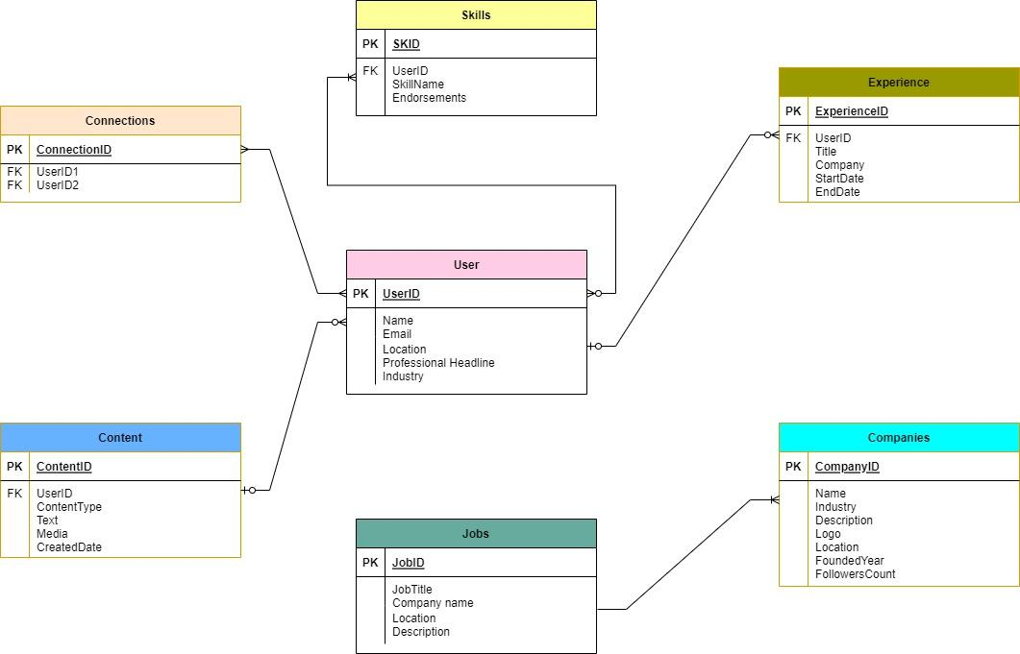

**Conclusion :**

Finally, LinkedIn has successfully addressed various real-world challenges through inventive solutions, establishing itself as a premier platform for professional networking and career growth. It addresses issues such as networking, job searching, professional branding, skill development, industry insights, and global prospects. LinkedIn's success stems from its ability to create a holistic ecosystem for professionals to interact, learn, and progress their professions in a globally interconnected digital world.